**Assignment - Parent to Child data flow**

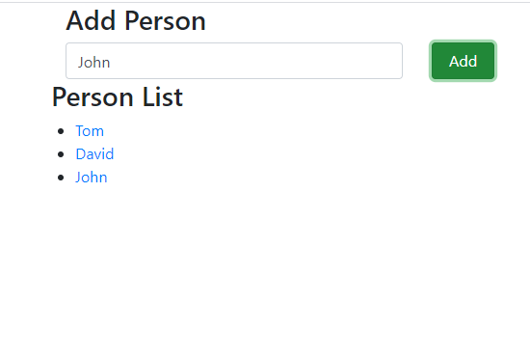

**Note**:

1. design and develop the screen like above.
2. When user click on Add button, it should add and display the added person name in the person list.

**Ex**. If I click on Add button after typing John then John name is displaying under person list.

1. This will be parent to child data flow.
2. You can create two components.
3. Parent component should have input text box and Add button
4. Child component should display person list
5. You can use bootstrap to develop components view